Experiment No. 11

Aim : Implementation of programs demonstrating different types of layout managers.

1. Border Layout: Implement following Example of Border Layout

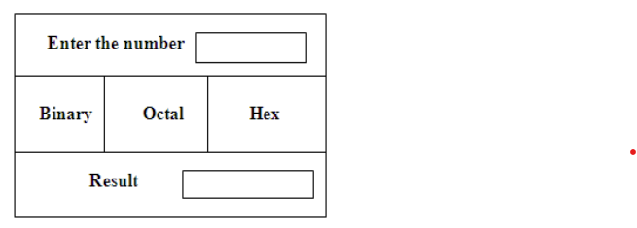

import javax.swing.*;
import java.awt.*;
import java.awt.event.*;

public class BorderLayoutDemo extends JFrame implements ActionListener {

JTextField inputField, resultField;
JButton binaryBtn, octalBtn, hexBtn;

public BorderLayoutDemo() {

setTitle("BorderLayout Example");
setSize(400, 250);
setDefaultCloseOperation(JFrame.EXIT_ON_CLOSE);

setLayout(new BorderLayout(10, 10));

// Top Panel (NORTH)
JPanel topPanel = new JPanel();
topPanel.add(new JLabel("Enter the number: "));
inputField = new JTextField(10);
topPanel.add(inputField);
add(topPanel, BorderLayout.NORTH);

// Center Panel (CENTER)
JPanel centerPanel = new JPanel(new GridLayout(1, 3, 10, 10));

binaryBtn = new JButton("Binary");
octalBtn = new JButton("Octal");
hexBtn = new JButton("Hex");

centerPanel.add(binaryBtn);
centerPanel.add(octalBtn);
centerPanel.add(hexBtn);

add(centerPanel, BorderLayout.CENTER);

// Bottom Panel (SOUTH)
JPanel bottomPanel = new JPanel();
bottomPanel.add(new JLabel("Result: "));
resultField = new JTextField(10);
resultField.setEditable(false);
bottomPanel.add(resultField);

add(bottomPanel, BorderLayout.SOUTH);

// Add action listeners
binaryBtn.addActionListener(this);
octalBtn.addActionListener(this);
hexBtn.addActionListener(this);

setVisible(true);
}

@Override
public void actionPerformed(ActionEvent e) {
try {
int num = Integer.parseInt(inputField.getText());

if (e.getSource() == binaryBtn) {
resultField.setText(Integer.toBinaryString(num));
} else if (e.getSource() == octalBtn) {
resultField.setText(Integer.toOctalString(num));
} else if (e.getSource() == hexBtn) {
resultField.setText(Integer.toHexString(num).toUpperCase());
}

} catch (NumberFormatException ex) {
JOptionPane.showMessageDialog(this, "Please enter a valid number!");
}
}

public static void main(String[] args) {
new BorderLayoutDemo();
}
}
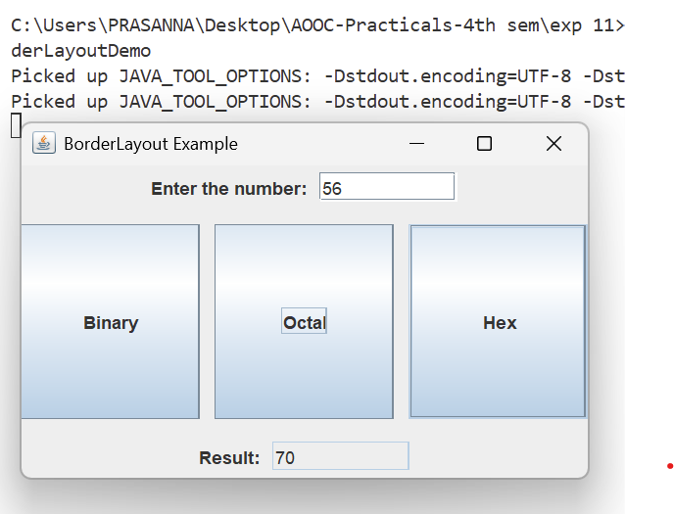
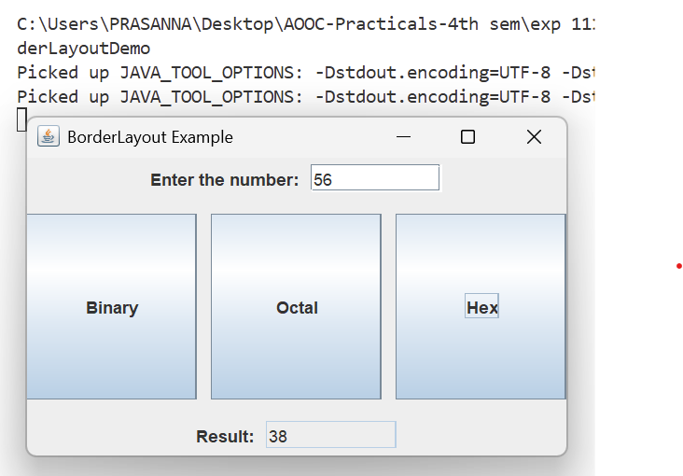
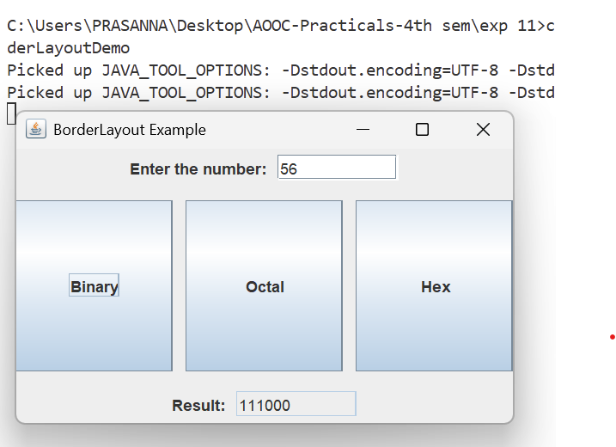

2. FlowLayout: Create a Java program using FlowLayout (aligned left, with horizontal gap 10px and vertical gap 20px) that adds three checkboxes labeled "Java", "Python", and "C++" into the frame.

import javax.swing.*;
import java.awt.*;

public class FlowLayoutDemo extends JFrame {

public FlowLayoutDemo() {

setTitle("FlowLayout Example");
setSize(300, 150);
setDefaultCloseOperation(JFrame.EXIT_ON_CLOSE);

// FlowLayout: LEFT alignment, hgap = 10, vgap = 20
setLayout(new FlowLayout(FlowLayout.LEFT, 10, 20));

// Create Checkboxes
JCheckBox java = new JCheckBox("Java");
JCheckBox python = new JCheckBox("Python");
JCheckBox cpp = new JCheckBox("C++");

// Add to frame
add(java);
add(python);
add(cpp);

setVisible(true);
}

public static void main(String[] args) {
new FlowLayoutDemo();
}
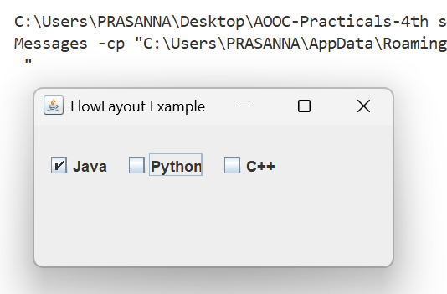
}

3. GridLayout: Create a program that demonstrates the use of GridLayout. Display a 2x3
grid with the following numbers inside each box. Also, when the user clicks on any box, the
number inside that box should swap with the number

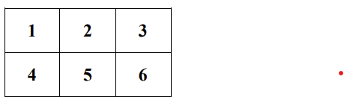

import javax.swing.*;
import java.awt.*;
import java.awt.event.*;

public class GridLayoutSwapDemo extends JFrame implements ActionListener {

JButton[] buttons = new JButton[6];
int firstIndex = -1; // to store first clicked button

public GridLayoutSwapDemo() {

setTitle("GridLayout Swap Demo");
setSize(300, 200);
setDefaultCloseOperation(JFrame.EXIT_ON_CLOSE);

// 2 rows, 3 columns
setLayout(new GridLayout(2, 3, 5, 5));

// Numbers to display
for (int i = 0; i < 6; i++) {
buttons[i] = new JButton(String.valueOf(i + 1));
buttons[i].setFont(new Font("Arial", Font.BOLD, 20));
buttons[i].addActionListener(this);
add(buttons[i]);
}

setVisible(true);
}

@Override
public void actionPerformed(ActionEvent e) {

// Find which button was clicked
for (int i = 0; i < 6; i++) {
if (e.getSource() == buttons[i]) {

if (firstIndex == -1) {
// First click
firstIndex = i;
buttons[i].setBackground(Color.LIGHT_GRAY); // highlight
} else {
// Second click → swap
String temp = buttons[firstIndex].getText();
buttons[firstIndex].setText(buttons[i].getText());
buttons[i].setText(temp);

// Reset color
buttons[firstIndex].setBackground(null);
firstIndex = -1;
}
break;
}
}
}

public static void main(String[] args) {
new GridLayoutSwapDemo();
}
}

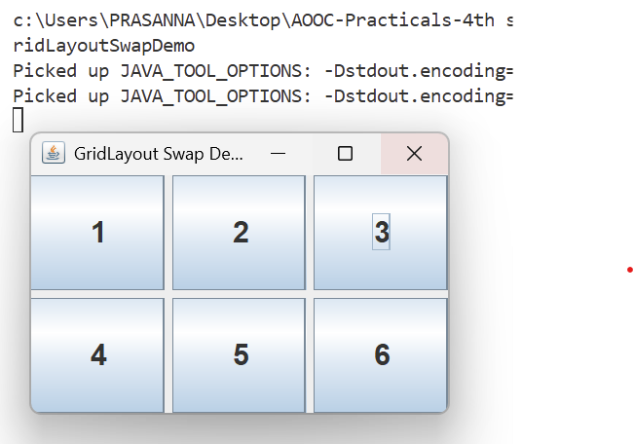
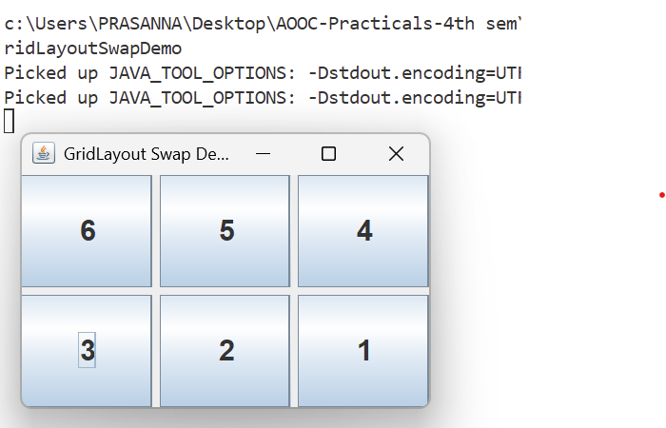
OUTPUT :

4. Write a GUI program to find the factorial of a given number using applet. (You will need
Java 8 to run applet)
How to compile and execute applet (You will need Java 8 to run applet)
Lab Manual: AOOC
Lab manual: Advanced Object-Oriented Concepts (Java), SY CSE, Sem IV, 2025-26,
Computer Science & Engineering Dept., D.Y. Patil College of Engineering & Technology, Kasaba Bawada, Kolhapur
Page 118 of 145
○ Compile the Applet - javac factorialappl.java
○ Run with Applet Viewer - appletviewer factorialappl.java
○ OR if using the HTML file -
■ Create an HTML File (if not using appletviewer)
■ Save below as factorial.html
<html>
<body>
<applet code="factorialappl.class" width="400" height="400"></applet>
</body>
</html>
■ appletviewer factorial.html

import java.applet.Applet;
import java.awt.*;
import java.awt.event.*;

public class factorialappl extends Applet implements ActionListener {

Label l1, l2;
TextField t1, t2;
Button b1;

public void init() {

l1 = new Label("Enter Number:");
l2 = new Label("Factorial:");

t1 = new TextField(10);
t2 = new TextField(10);
t2.setEditable(false);

b1 = new Button("Find Factorial");

add(l1);
add(t1);
add(b1);
add(l2);
add(t2);

b1.addActionListener(this);
}

public void actionPerformed(ActionEvent e) {
try {
int num = Integer.parseInt(t1.getText());
long fact = 1;

for (int i = 1; i <= num; i++) {
fact *= i;
}

t2.setText(String.valueOf(fact));

} catch (NumberFormatException ex) {
t2.setText("Invalid Input");
}
}
}

OUTPUT :

